**Database Systems**

Lab Manual 7

**Learning Objectives**

* Integrate Microsoft RDLC Report Viewer in Visual Studio.

## LO1: Integrate Microsoft RDLC Report Viewer in Visual Studio.

### Creating a Sample database and table

1. Execute the following MySQL script in MySQL Workbench

|  |
| --- |
| CREATE DATABASE company;  USE company;  CREATE TABLE EmployeeData (  EmployeeID INT AUTO_INCREMENT PRIMARY KEY,  FirstName VARCHAR(50),  LastName VARCHAR(50),  Department VARCHAR(50),  Salary DECIMAL(10,2)  );  INSERT INTO EmployeeData (FirstName, LastName, Department, Salary) VALUES  ('John', 'Doe', 'HR', 50000),  ('Jane', 'Smith', 'IT', 70000),  ('Robert', 'Brown', 'Finance', 60000); |

### Install Microsoft RDLC Report Designer 2022

1. Open the link: <https://marketplace.visualstudio.com/items?itemName=ProBITools.MicrosoftRdlcReportDesignerforVisualStudio2022>
2. Click on “Get Started”. This will start the downloading of the extension.
3. Once downloaded, run the file. Then click on “Install”. This will complete the installation on its own. After the installation click on Close.
4. Repeat the Same above 3 steps but with the link: <https://marketplace.visualstudio.com/items?itemName=ProBITools.MicrosoftReportProjectsforVisualStudio2022>

### Configuring MySQL ODBC Driver

1. 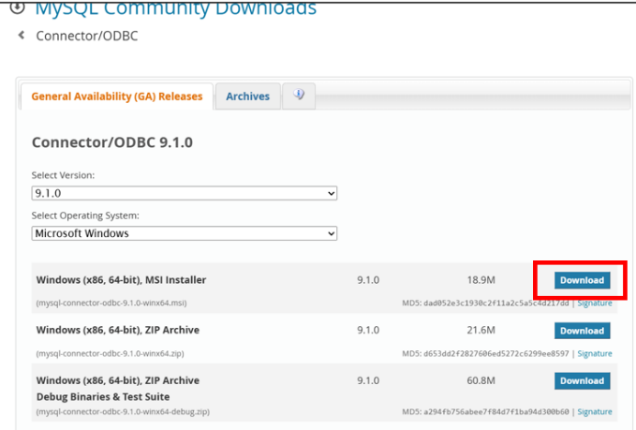Open the following link: <https://dev.mysql.com/downloads/connector/odbc/>. And click download for the **Windows (x86, 64-bit), MSI Installer**

Figure ODBC Driver Installation

1. 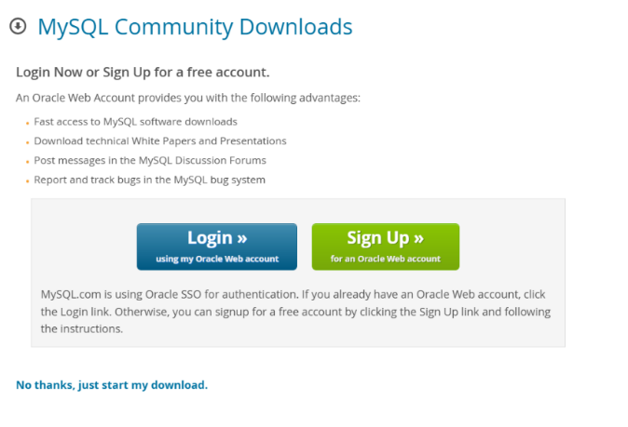Then on the new page that pops up click on “No Thanks, just start my download”.

Figure Download Confirmation

1. After downloading run the installed file. Make sure you have “Complete” checked on the setup type window then click on Next and then Install.

Figure ODBC Setup Type

1. 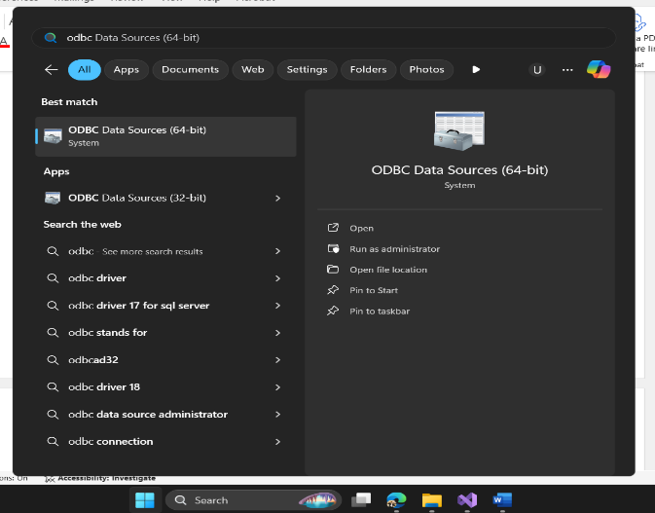In windows search bar type “ODBC Data Sources (64-Bit)” and open the app.

Figure ODBC Data Source App

1. Click on **“ADD”**

Figure User Data Sources

1. A screenshot of a computer

   Description automatically generatedFrom the options available select “MySQL ODBC 9.1 Unicode Driver” and click on Finish

Figure MySQL data source

1. In the Configuration window type in the details like Server IP, Port, User, Password and after these from the database dropdown select company and then click on OK

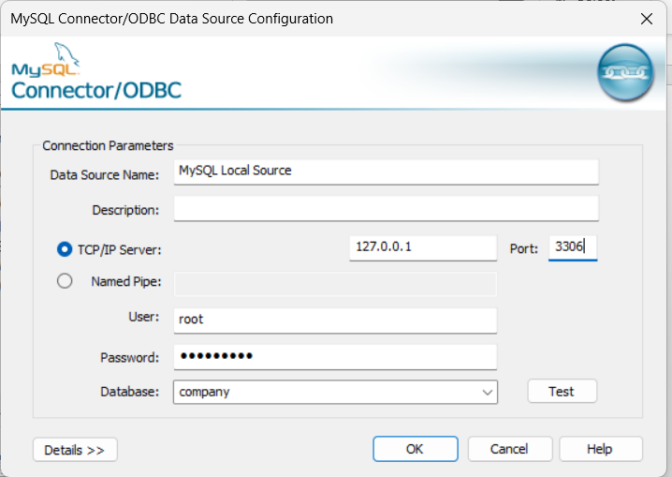

Figure MySQL Data Source Configuration

### Prepare Visual Studio Project for Report

1. Open Visual Studio and click “Create a new Project”.
2. On the search bar type: “Windows Forms App (.NET Framework)”.

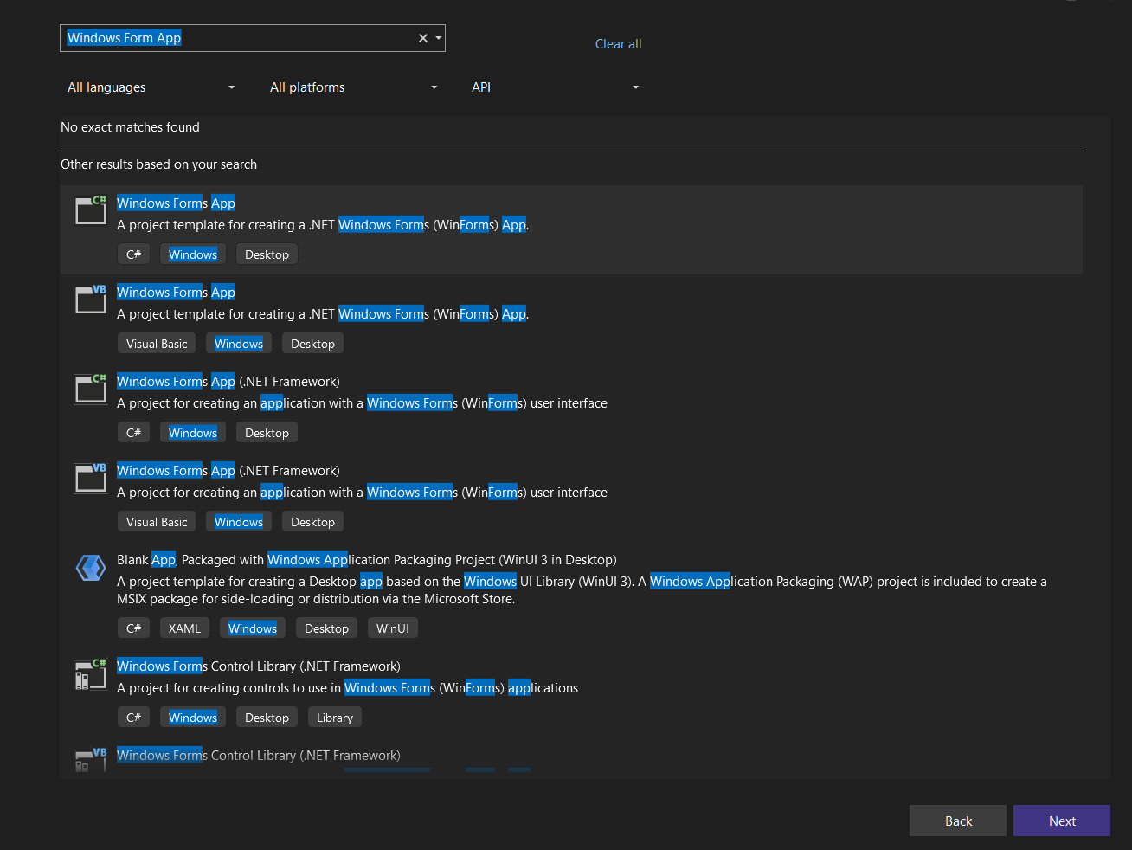

Figure Visual Studio Project Create

1. From the list select the one that has “C#”, “Windows”, “Desktop”. And then click on Next. Complete next project setup options like name, location, etc.
2. Once Completed, open the project. From the top bar select **Tools->NuGet Package Manager->Package Manager Console.**

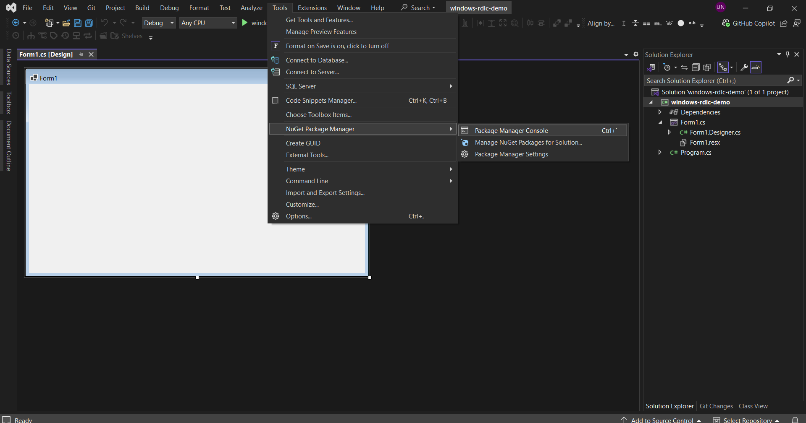

Figure Package Manager Console

1. Type in the following command in the console and hit enter.

Install - Package Microsoft.ReportingServices.ReportViewerControl.Winforms -Version 150.1652.0

1. Once Installed, on the solution explorer, right click on your project and go to **Add->new Item**.

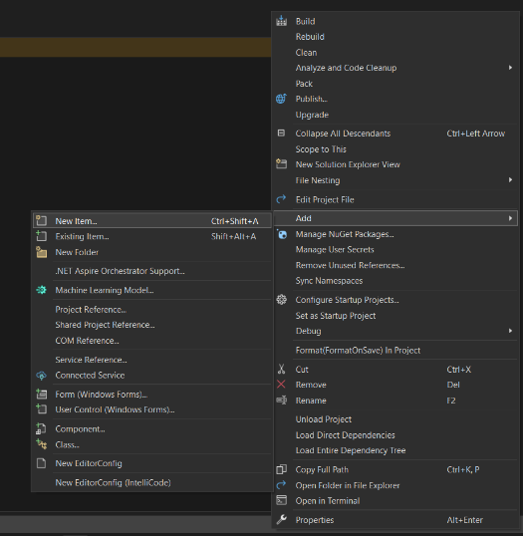

Figure Add Item To Project

1. Create a C# class named: “EmployeeData”. This class will be the model for our database table we created earlier. The structure of the class will be:

|  |
| --- |
| public class EmployeeData  {  public int EmployeeID { get; set; }  public string FirstName { get; set; }  public string LastName { get; set; }  public string Department { get; set; }  public double Salary { get; set; }  } |

1. From the top bar select **Build->Rebuild Solution**.
2. On the solution explorer, right click on your project and go to: **Add->New Item.**
3. In the top right, type “Report” in search bar. Under all the options available select “Report” and click on Add.
4. Double click on the newly added item from the solution explorer and then do the following shortcut key: **“CTRL + ALT + D”** if Report Data window already not present.
5. From the Report Data tab, Select “**New->Dataset**”.

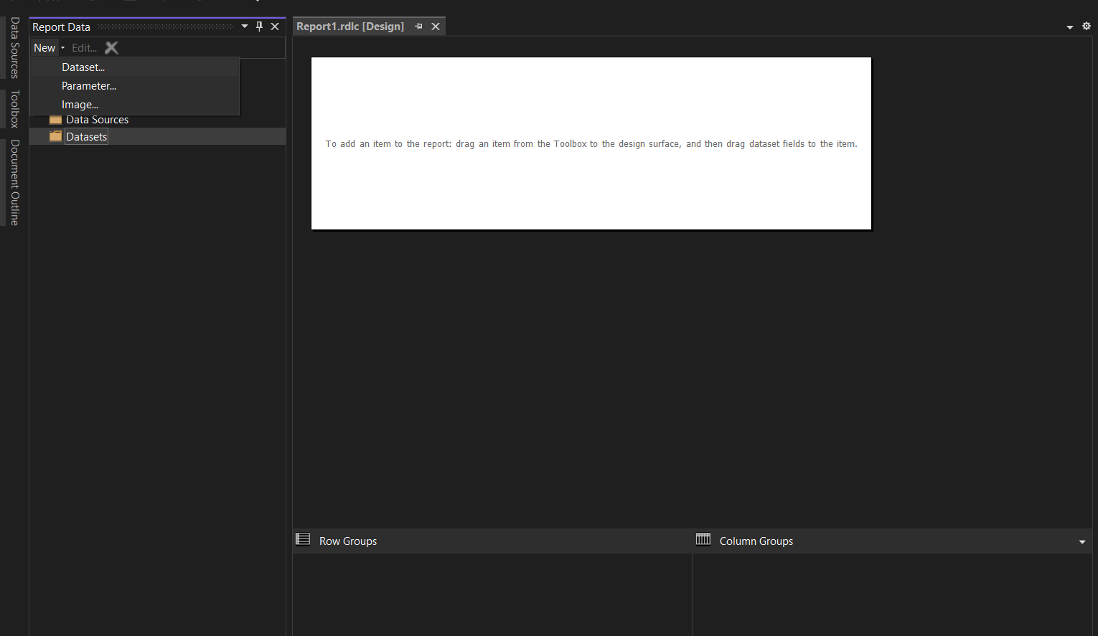

Figure Add Dataset to Report

1. 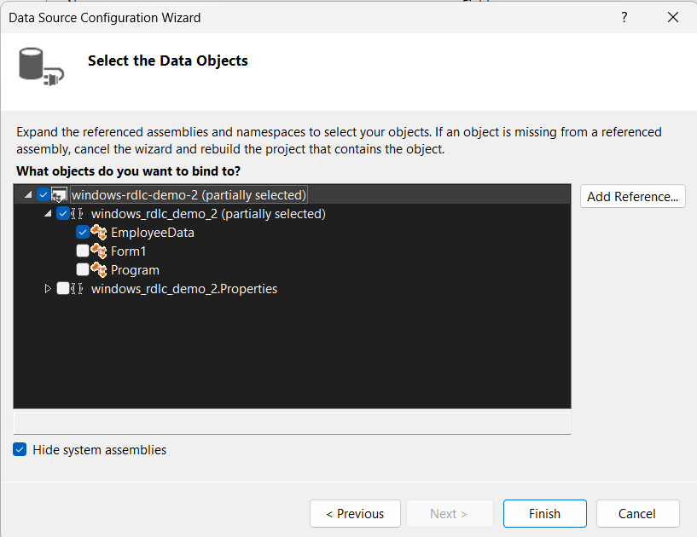In the Data Source Configuration Wizard, select “Object” and then Next. In the next window select your “EmployeeData” class from the dropdown, and then click Finish and then OK.

Figure Data Class Selection

1. While staying in the Report1.rdlc hit the shortcut key: **“CTRL+ALT+X”**, it will open the toolbox side bar. Then drag a text box inside the white box area of the report
2. Double click the text box and type “Employee Data” in it.
3. Drag a table from the toolbox into the report and adjust its height, width, and position in the report.
4. Right click the table and click on Insert Column, Make sure your table has 5 columns (Based on 5 attributes of our Class) if not Insert that many columns.
5. Under the header of every Cell there is a small icon which appears when mouse is over it like in the image below.

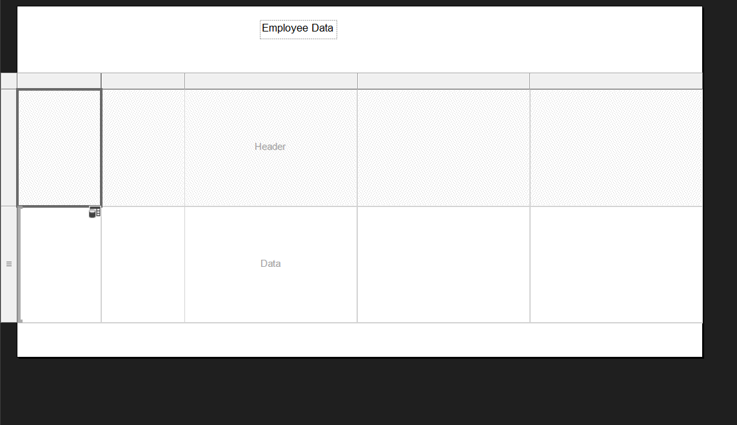

Figure Report Structure

1. Click on each icon and map the column you want to display inside it
2. When every column is mapped your report will look like the image below

Figure Report Structure With Table Mapping

1. Save the report (You can build and design your complete report as you want).
2. Open the Form1.cs
3. In the tool box scroll down till “General” Section. Right click on general and select “Choose Items”.
4. Once the window is loaded, click on browse.
5. From the dialog box open your project’s folder and go to

**(Your Project Path)->Packages->Microsoft.ReportingServices.ReportViewerControl.Winforms.150.1652.0->lib->net40**

1. From the folder select the file named: “Microsoft.ReportViewer.WinForms.dll” and then click Open and then OK.
2. Now in general section you will see “ReportViewer”.
3. Drag and drop that report inside your form window and click “Dock in Parent Container”.
4. From Choose Report dropdown select your report you just created.
5. Click on Choose Data Source
6. Under the dropdown of Data Source Instance select: **“Other data sources->project Data Sources->EmployeeData”** and then click OK.
7. In your form window right click and select “View Code”.
8. See the function Form1_load: before the line of RefreshReport() you have to add your code to fetch data from the database, but for now lets do it with dummy data

|  |
| --- |
| private void Form1_Load(object sender, EventArgs e)  {  // Add logic to fetch data from database  this.employeeDataBindingSource.DataSource = new List<EmployeeData>()  {  new EmployeeData(){ EmployeeID = 1, FirstName = "John", LastName="Doe", Department = "HR", Salary = 50000.00 },  new EmployeeData(){ EmployeeID = 2, FirstName = "Jane", LastName="Smith", Department = "IT", Salary = 70000.00 },  new EmployeeData(){ EmployeeID = 3, FirstName = "Robert", LastName="Brown", Department = "Finance", Salary = 60000.00 },  };  this.reportViewer1.RefreshReport();  } |

1. A screenshot of a computer

   Description automatically generatedSave the File and then run the project. This will open the data we just added in the load function.

Figure Report in App

1. Microsoft RDLC Report Viewer provides features like printing the report or exporting in pdf, Viewing in the print layout style staying in the app. You can also set the export option as pdf, word, or excel.

**Lab Tasks**

**Task 1: Replace Dummy Data with Database Data**

1. Replace the dummy data in your Microsoft RDLC report with real data fetched from the company database.
2. Use a Products table to display Product Name, Unit Price, and Quantity Per Unit in the report.
3. Ensure you write the necessary SQL query in your C# code and bind the resulting data to the report.

**Task 2: Create a Report for Employees**

1. Create a new RDLC report that lists the Employee Name, Title, and Hire Date from the Employees table.
2. Include a filter option where users can view employees hired after a specific date. Implement this filter in your C# code.
3. Add a professional-looking header with the title "Employee Details Report."

**Task 3: Create a Sales Report by Region**

1. Create another RDLC report to display Region, Order ID, and Order Date from the Orders table, grouped by region.
2. Add a summary at the end of the report to show the total number of orders for each region.
3. Ensure proper formatting for dates and numeric values in the report.